EXPERIMENT 9: BI SECURITY USING MICROSOFT POWER BI
1. Aim
To understand BI security concepts, including authentication, authorization, access control, and Row-Level Security (RLS), using Microsoft Power BI.
2. Implementation
Three report pages were created using the Global Superstore dataset.
Page 1: User Access Overview
This page displays four KPI cards: Total Users, Total Roles, Protected Regions, and Access Levels. A clustered column chart, Users by Role, shows the distribution of organizational users across different roles.
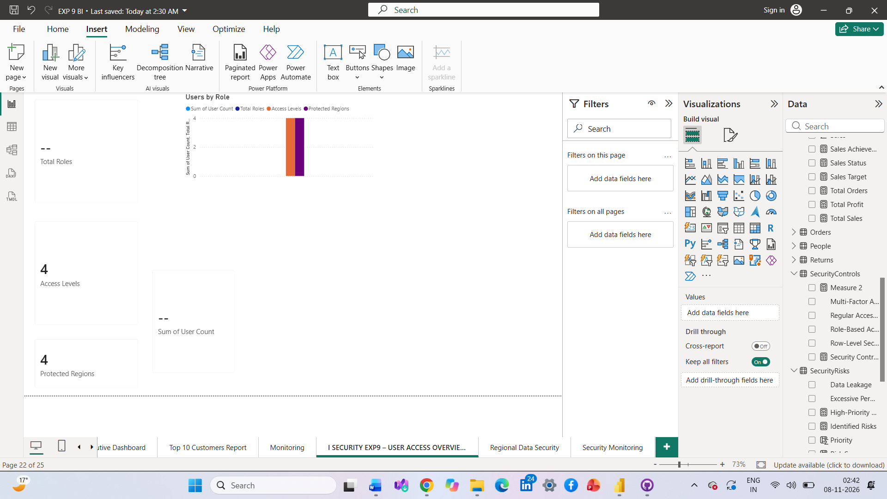Page 2: Regional Data Security
This page displays Total Sales, Total Profit, and Total Orders through KPI cards. It also includes Sales by Region and Profit by Region charts, along with a Region slicer. The page supports the demonstration of Row-Level Security, restricting regional managers to their assigned regional data.
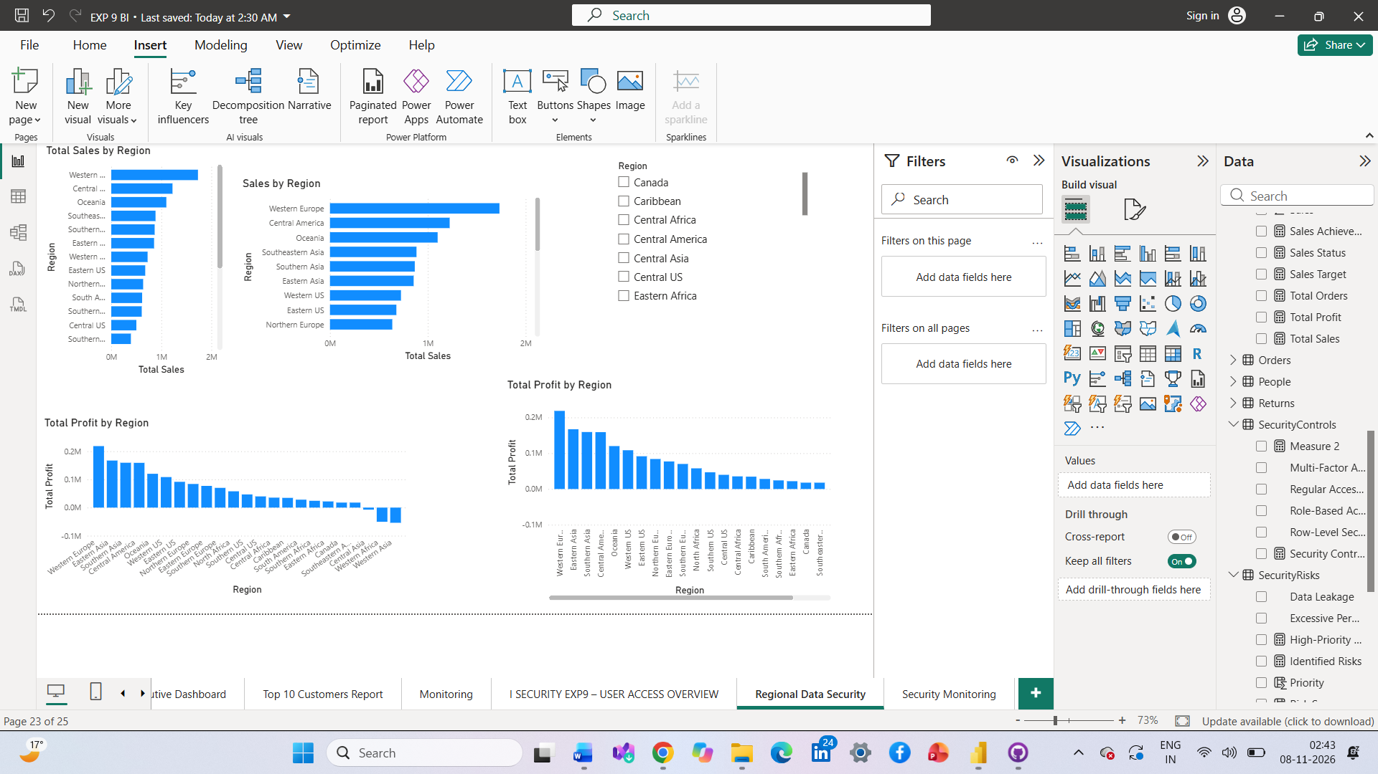Page 3: Security Monitoring
This page presents security risks and recommended controls. It includes KPI cards for Identified Risks, Security Controls, High-Priority Risks, and Protected Regions. Two charts display Security Risks by Priority and Recommended Security Controls.
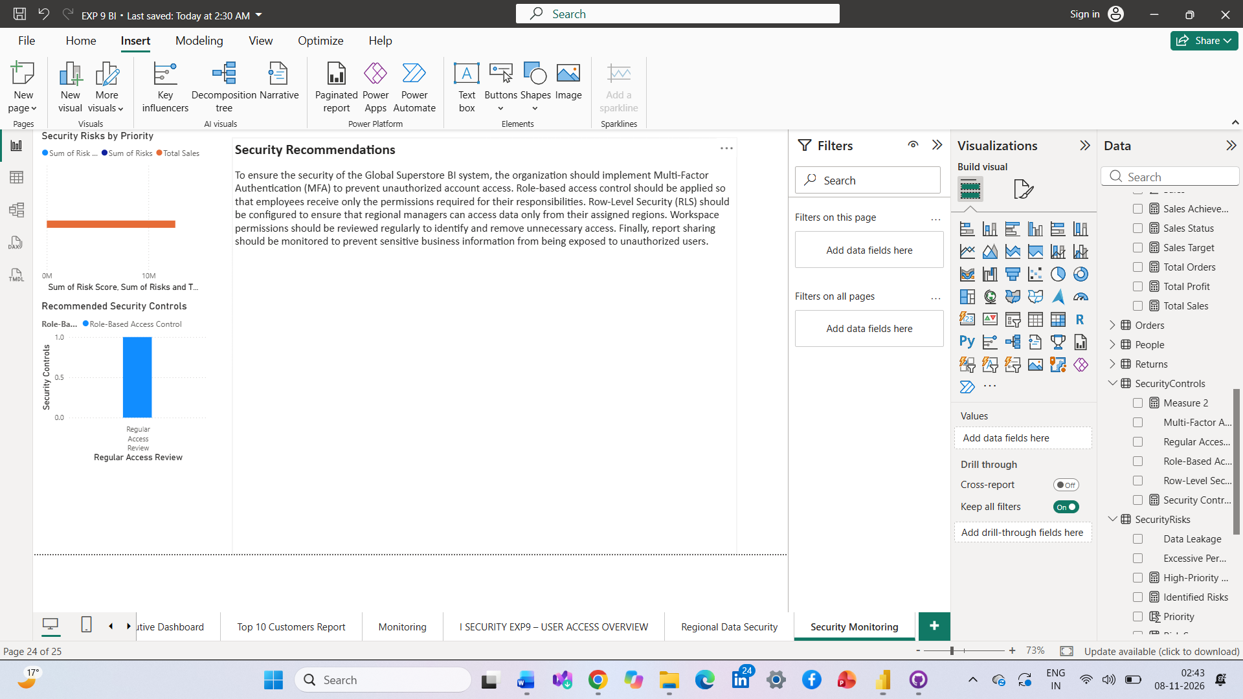3. Security Recommendations
Multi-Factor Authentication should be used to strengthen authentication. Role-based permissions and RLS should restrict access to authorized information. Workspace permissions should be reviewed regularly, and report sharing should be monitored to prevent data leakage.
4. Result
Three Power BI report pages were designed to demonstrate user access management, regional data security, and BI security risk monitoring for the Global Superstore organization.
5. Learning Outcomes
- Understood authentication and authorization.
- Learned about user roles and access permissions.
- Understood Row-Level Security in Power BI.
- Identified BI security risks and recommended appropriate controls.

